Design Pattern and Principals

Superset ID- 6363229

**Exercise 1: Implementing the Singleton Pattern**

Logger.cs

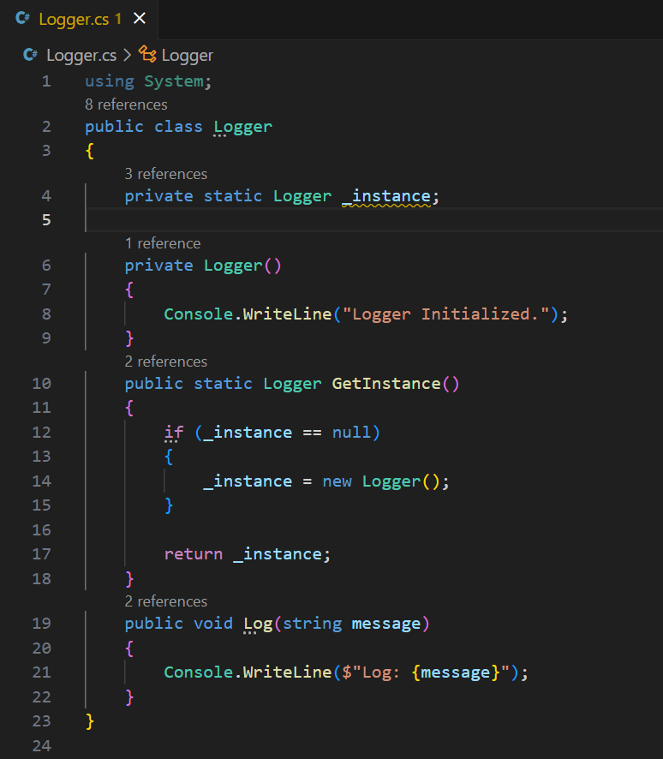

Program.cs

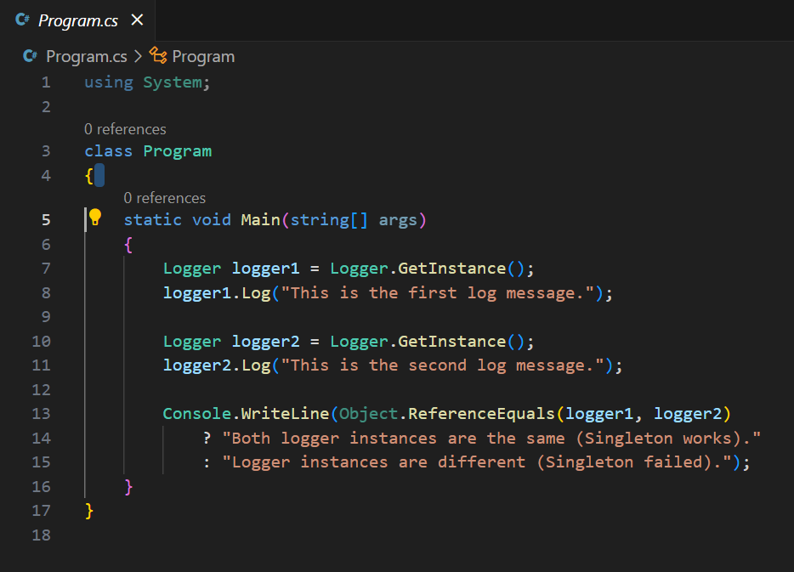

Output:

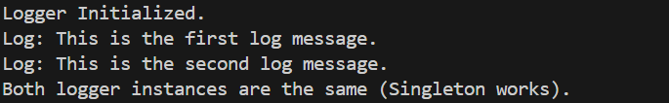

**Exercise 2: Implementing the Factory Method Pattern**

IDocument.cs

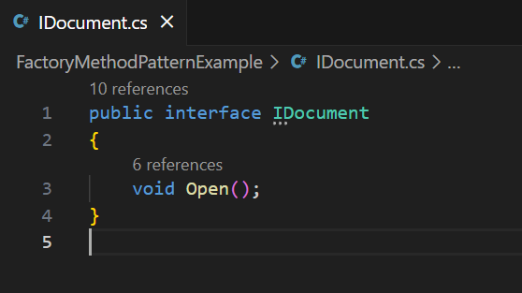

WordDocument.cs

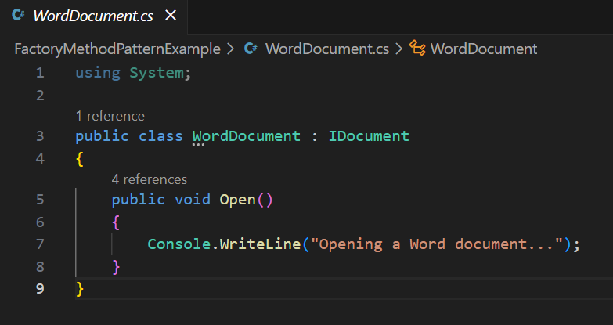

PdfDocument.cs

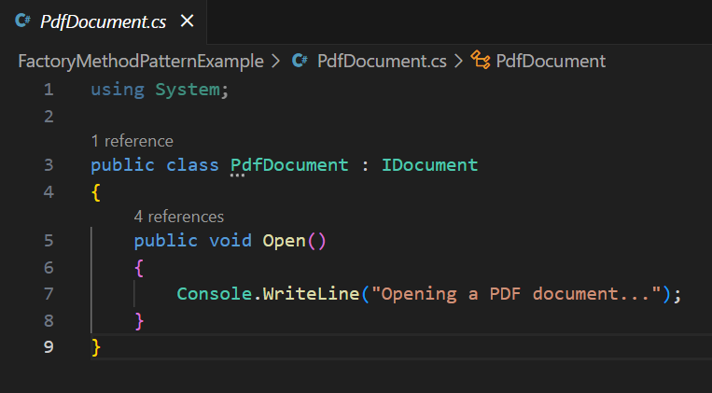

ExcelDocument.cs

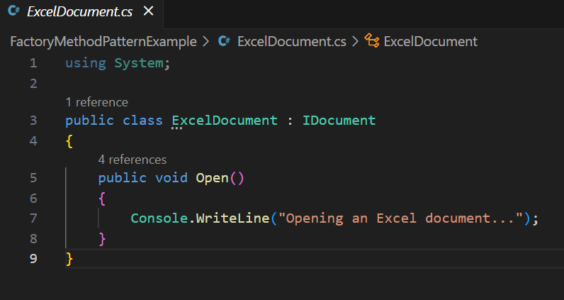

DocumentFactory.cs

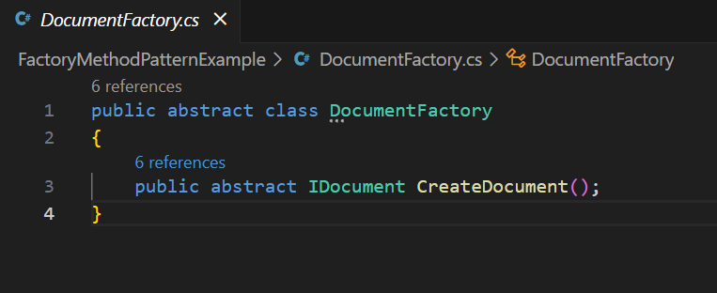

WordDocumentFactory.cs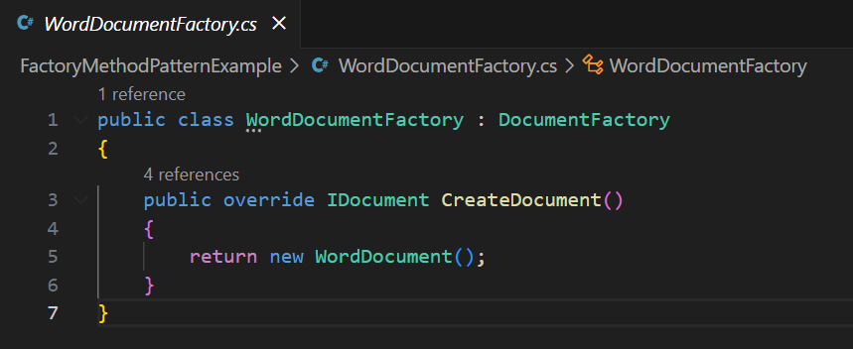

PdfDocumentFactory.cs

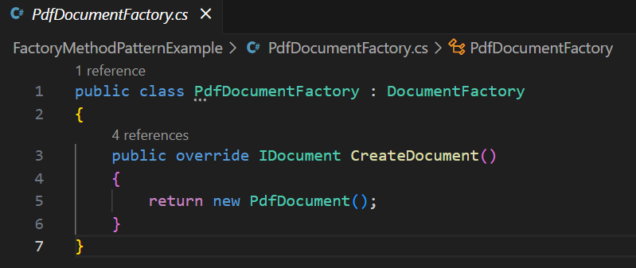

ExcelDocumentFactory.cs

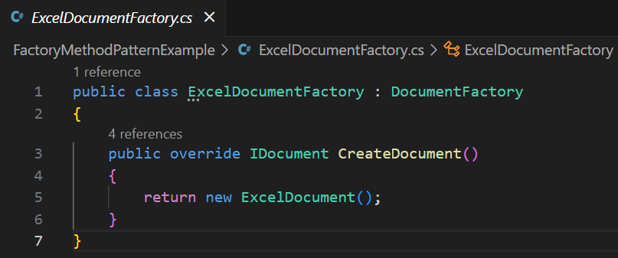

Program.cs

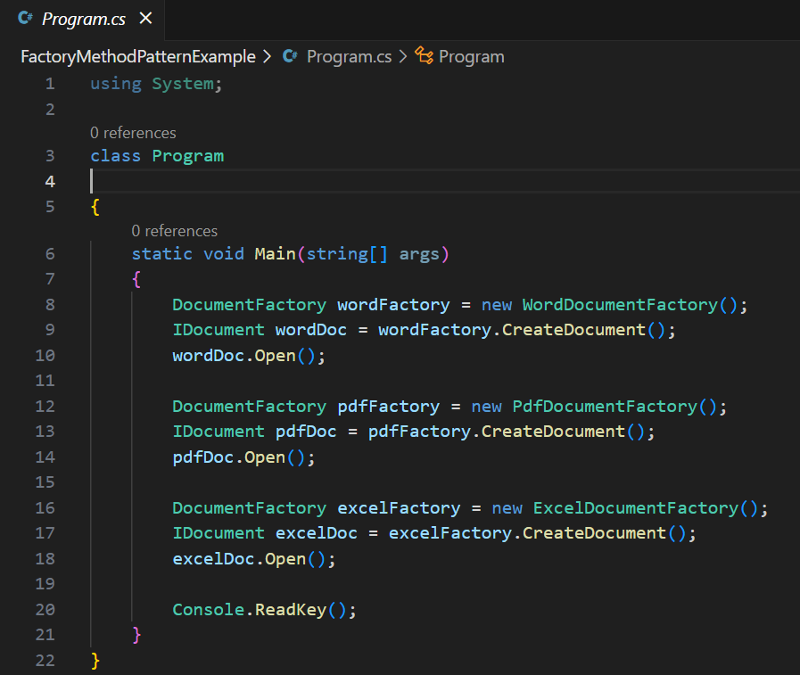

Output:

